EXP NO:04 DATE:
DESIGN OF REGULATED POWER SUPPLY CIRCUIT USING A VOLTAGE REGULATOR IC-LT SPICE
AIM
To design a regulated power supply circuit using a voltage regulator IC, simulate the circuit in LTspice, and test its performance for different load conditions.
SOFTWARE REQUIRED
- LTSpice Simulator

THEORY
A regulated power supply is an electronic circuit that provides a stable and constant DC voltage output, regardless of input fluctuations or load variations. It typically includes components like a transformer, rectifier, filter, and voltage regulator to ensure reliable operation of electronic devices. A 5V regulated power supply circuit using a voltage regulator IC ensures a constant 5V DC output. The circuit typically includes a step-down transformer, rectifier, filter capacitor, and a 7805 voltage regulator IC. The step-down transformer reduces high AC voltage to a lower level (e.g., 12V AC). A bridge rectifier (four diodes) converts the AC voltage to pulsating DC. A capacitor (e.g., 470µF) smooths the DC voltage by filtering ripples. The 7805 voltage regulator IC maintains a steady 5V output despite input variations. Small ceramic capacitors (0.01µF) are placed at the input and output of the 7805 to improve stability. A heat sink may be attached to the 7805 to prevent overheating. The circuit provides a reliable 5V source for microcontrollers, sensors, and other low-power devices. It is a simple, cost-effective solution for powering 5V electronic circuits.

PROCEDURE:

- Open LTspice and Create a New Schematic
- Place the Circuit Components
- Wire the Components
- Set Component Values
- Add a Simulation Command
- Place the Simulation Command on the Schematic
- Run the Simulation
- Analyze the results

CIRCUIT DIAGRAM

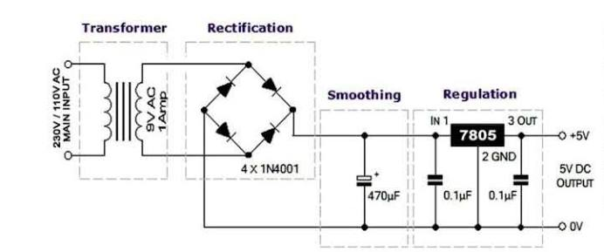
MODEL GRAPH
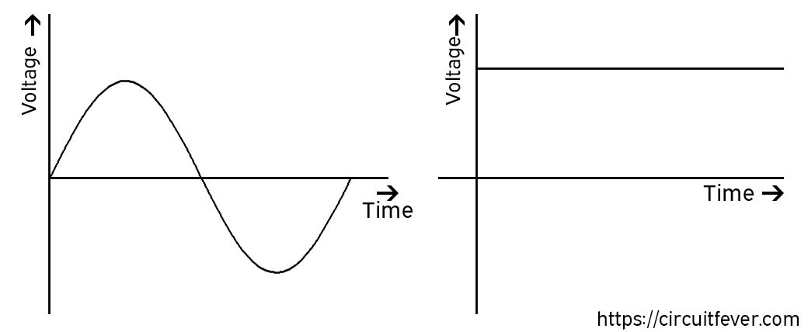

RESULT
Thus a regulated power supply circuit using a voltage regulator IC was designed and the circuit was simulated using LTspice and its performance for different load conditions was tested.

